 | 99-9999-TYPE-SITE
 | AUG 4, 2011
 | X.Y-DNM

IPU SDK User Guide
Abstract:
This document is written to describe how to use the Os-agnostic IPU SDK, the data structures and the APIs.

Keywords:
OS-agnostic, IPU, SDK

Approved:
 | Author | KARL LU

Revision History
Version | Date | Author | Change Description
0.1 | 4 May 2011 | Jerry Fan | Initial Document

Table of Contents
SDMA SDK User Guide i
1 Introduction 1
1.1 Purpose 1
1.2 Scope 1
1.3 References 1
1.4 Glossary 1
1.5 Document Location 2
1.6 Problem Reporting Instructions 2
2 System Overview 3
2.1 Scripts 3
2.2 Channels and Channel Descriptor 4
2.3 Buffer Descriptor and BD chain 4
3 Application Program Interface 6
4 Development Notes 9

Introduction

Purpose
This document introduces the general architecture of SDMA core on i.MX SoCs and elaborates the software design on how to use the SDMA scripts provided to support various kinds of DMA transfer targeted to peripherals and internal and external memories.

Scope
The intended audience is the driver programmers that make use of SDMA.

References
Title | Reference | Version | Location
i.MX53 Multimedia Applications Processor Reference Manual |  | Rev 1A | http://cache.freescale.com/files/32bit/doc/ref_manual/iMX53RM.pdf?fsrch=1&sr=8

Glossary
Term/Acronym | Definition
SDMA | Smart Direct Memory Access
SPBA | Shared Peripheral Bus Arbiter
WML | Water Mark Level, lower or upper threshold that triggers a DMA request to the SDMA
CCB | Channel Control Block
BD | Buffer Descriptor
Scripts | SDMA program executed on a channel
channel | Manages a flow of data execution, typically unidirectional. SDMA supports up to 32 channels
DMA event | Caused by external controlled condition like receive FIFO reaches a threshold. SDMA supports up to 48 DMA events
TZ | Trust Zone
AP | Application Processor

Document Location
(TBD)

Problem Reporting Instructions
Mail to: karl.lu@freescale.com

System Overview
The Smart Direct Memory Access controller is composed of a RISC core together with ROM, RAM and scheduler. So programs dedicated for various kinds of DMA transfer could be loaded into and run in this core.
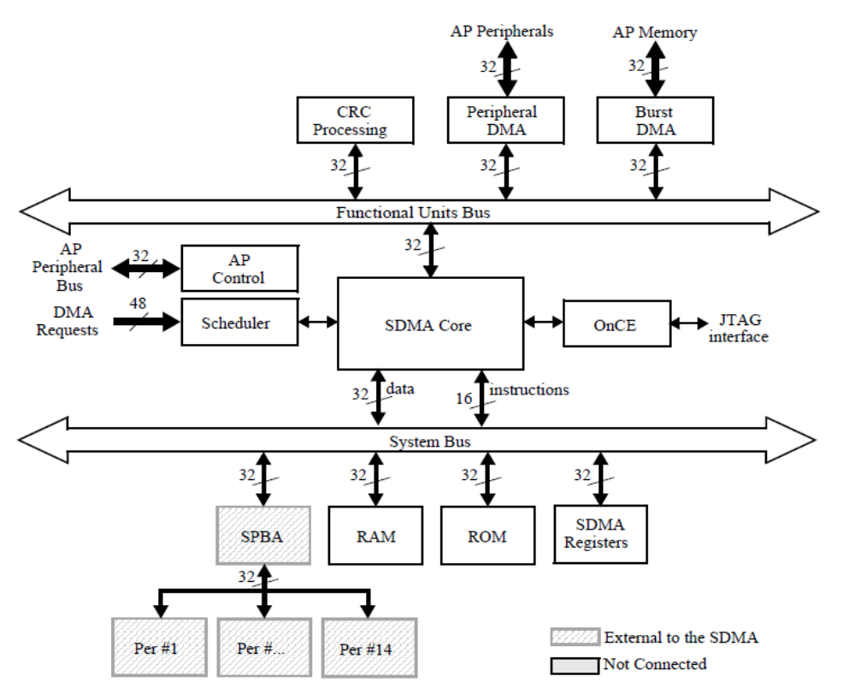
Figure 2.1 SDMA Block Diagram

Scripts
A set of scripts are provided to perform DMA transfers among the memories and peripherals. These scripts each support one type of transfer, like memory to peripheral and peripheral to memory etc. Some scripts are dedicated to specific peripheral with some feature turned on. See Script Manual for details.
There’re three types of access for SDMA to memories and peripherals. To AP memories, no matter internal or external, burst access is supported. To AP peripherals, access could be Per DMA through Functional Unit bus or SPBA through SPBA bus. Note that some peripheral reside on the Trust Zone off platform, thus need to turn off the TZ to enable the SDMA access.
In terms of where resided, the scripts are separated into two parts: ROM scripts and RAM scripts. If want to use RAM scripts, user need to download the RAM scripts into SDMA RAM through the channel 0 which script is inside the ROM. According to the input parameters, channel 0 script also could download other channel’s context data to SDMA RAM.

Channels and Channel Descriptor
There’re up to 32 time-division processes with its priority, DMA event map, context area and CCB supported, called channels. The scheduler provides hardware based coordination among the active channels. Context area is used to store the SDMA core’s context and CCB is used to manage the buffer descriptor list.
The SDMA API provides a data structure named sdma_chan_desc_t to descript the information of the channels.
typedef struct {
unsigned int script_addr;
unsigned int gpr[8];
unsigned int dma_mask[2];
unsigned char priority;
unsigned int nbd;
} sdma_chan_desc_t, *sdma_chan_desc_p;

script_addr : script’s address the channel use.
gpr[8] : some parameters which will be used by the script, such as watermark, etc. User may refer to the appendix A “SDMA script” in “iMX53 AP RM” (see 1.3 References) to get the details for each script.
dma_mask[2] : the event the channel be triggered User may refer to the chapter “Interrupts and
DMA Events” in the SOC’s reference manual for the details.
priority: the priority of the channel(0-7).
nbd: the number of buffer descriptor the channel has.
This structure together with buffer descriptor is needed by SDMA API to request a channel. User may setup this structure before request a channel.

Buffer Descriptor and BD chain
SDMA scripts use the CCB to manage the buffer descriptors. In AP software, register of MC0PTR should be set to the address of CCB table of all 32 channels. In the channel script, according to the address in the MC0PTR and the channel number, script will know the base address of its CCB. The base address of buffer descriptors is provided in the CCB. So the commands and parameters in the BDs can be read and processed by the script to perform the transfer. User may refer to the script manual to get the detailed description of the BD usage for each script.
Typically, in the BD data structure (see Table 2.1), the first 32 bit word is called mode word; the next two words are base and extended buffer address. Table 3.3 shows the field layout:
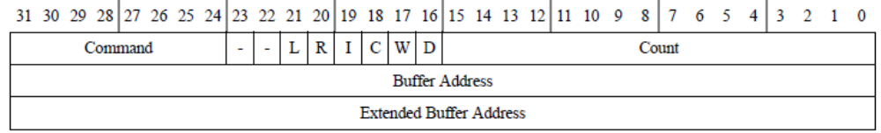
Table 2.1Buffer Descriptor Format
Description for some of the fields:
- Count: Number of bytes for this transfer
- D: D=0 means SDMA has done the transfer for this BD while D=1 means not
- W: Wrap. If W=1, after current BD is done, will wrap to the base BD(pointed by basdBDptr in CCB)
- C: Continuous. If C=1, after current BD is done, will move to the next BD
- I: Interrupt. If I=1, after current BD is done, will set the corresponding bit(according to the channel number) in SDMA interrupt register
- R: Error. If R=1, there’s error happened during current BD transfer
- L: Last buffer descriptor. This bit is set in SDMA IPC scripts to indicate to the receiving Core that the transfer has ended
- Command: This field is used to differentiate operations performed in the script. Usage of this field varies from script to script. Typically, bit 24 and 25 are used to indicate the bus width for many scripts.
If Continuous bit is set, the next BD right behind the current one will be processed after current one is finished. So with the Continuous bit set, BDs can constitute a BD chain. For one channel, up to 64 BDs can be supported in the chain. The Continuous bit of the last BD in the chain should be cleared.

Application Program Interface
int sdma_init(sdma_env_p envp, unsigned int base_addr)
Description: Initialize the system environment for SDMA. In this function will:
- Reset SDMA controller
- Setup configurations like AP DMA/SDMA clock ratio, CCB base address etc
- Use channel 0 script to load the RAM scripts into SDMA RAM
Parameters: envp uncacheable and unbufferable buffer allocated by user
base_addr base address of SDMA registers in AP
Return: 0 on success
-1 when fail to download RAM scripts to SDMA RAM
-2 when environment pointer is NULL
----
void sdma_deinit(void)
Description: De-initialize the SDMA environment. In this function will:
- Close and free all the channels
- Clear all the EP and overrides of channels
Parameters: none
Return: none
----
int sdma_channel_request(sdma_chan_desc_p cdp, sdma_bd_p bdp)
Description: Allocate a free channel and open it. In this function will:
- Validate the input parameters
- Find and allocate a free channel
- Setup the channel overrides, DMA masks, buffer descriptors, channel priority etc
- Write the channel context to SDMA RAM
Parameters: cdp A pointer to user provided data. It includes necessary channel descriptors
of:
script_addr script address in SDMA defined in sdma_script_code.h.
gpr[8] normally it includes the FIFO address, DMA mask,
watermark etc. User could refer to the script manual
released with the sdma_script_code.h for details.
dma_mask[2] DMA mask to set in register of channel enable.
Normally it's also provided in gpr[8]. We separate it here
to support some special script that may have some
different usage of GPRs.
priority the channel priority
bdp A pointer to the user provided buffer descriptor table.
Return: return the channel number on success
-2: at least one of user provided pointers is NULL
-3: channel priority exceeds limitation (1-7)
-4: no free channel that could allocate
-5: got failure when download channel context to SDMA RAM
-6: too many buffer descriptors in table (>64)
-7: SDMA is not initialized yet
----
int sdma_channel_release(unsigned int channel)
Description: Close the channel selected. This function will:
- stop and free the channel
- clear the EP if set
- reset the channel override
- reset the channel control block
Parameters: channel channel number
Return: 0 on success, -1 when channel number not in range (0-31) or SDMA not
initialized yet
----
int sdma_channel_start(unsigned int channel)
Description: Start the channel selected.
Parameters: channel channel number
Return: 0 on success, -1 when channel number is out of range (0-31) or channel is free
----
int sdma_channel_stop(unsigned int channel)
Description: Stop the channel selected.
Parameters: channel channel number
Return: 0 on success, -1 when channel number out of range (0-31)
----
int sdma_channel_status(unsigned int channel, unsigned int *status)
Description:
Parameters: channel channel number
status the pointer holds the channel’s status: error, done or busy
Return: 0 on success, -1 on failed
----
int sdma_lookup_script(script_name_e script, unsigned int *addr )
Description:
Parameters: script script name to lookup
addr the pointer holds the script’s address if the function return 0
Return: 0 on success, -1 on failed

Development Notes
User could use the API presented above for the SDMA transfer control. The demo below shows the typical usage of the API. For space saving, some pseudo code is used.
SDMA_demo{
Allocate uncacheable and unbuffereable memory for BDs, buffers,etc.
sdma_init();
Set up channel descriptors and BDs;
sdma_channel_request();
sdma_channel_start();
Wait for channel done;
sdma_channel_stop();
sdma_channel_release();
sdma_deinit();
}
Firstly the SDMA environment should be initialized with sdma_init. Before calling this function, user should have a static or dynamic allocated buffer to store the global variable used by the API. Note that this buffer is accessed by DMA thus should be uncacheable and unbufferable.
To initiate an SDMA transfer, user need to allocate a channel with sdma_channel_request with necessary inputs provided. These inputs are bundled in two data structures, say channel descriptor and buffer descriptor. User also needs to provide the buffer to store these data structures, and the buffer descriptors also should be in uncacheable and unbufferable region since they will be accessed by SDMA. sdma_script_lookup is used for searching the script’ address.
In the channel descriptor structure, user should set the channel attributes and necessary context contents like channel priority, which script to use, GPRs and so on. User may refer to the “Script Manual” released for each SoC to get the details for each script.
For SDMA transfer with DMA event not involved (memory to memory transfer triggered by HSTART), when the channel is open, user could start the SDMA transfer with sdma_channel_start right away. While for the rest transfer, user also need to configure and start the peripheral and enable the peripheral DMA control, then start the transfer.
If want to initiate this transfer later on, user may change the data in the buffer descriptor, then restart the channel with sdma_channel_start again. Or else, user may use sdma_channel_release to free the channel.
User may also stop the ongoing transfer with sdma_channel_stop. The sdma_deinit provides a way to re-initialize the SDMA together with the sdma_init.

